CHAPTER 3: Evolution
Worksheet 3.4

Fossils
Student: Class:

Archaeopteryx
1. The photo below shows the 150 million year old fossilised remains of an Archaeopteryx.
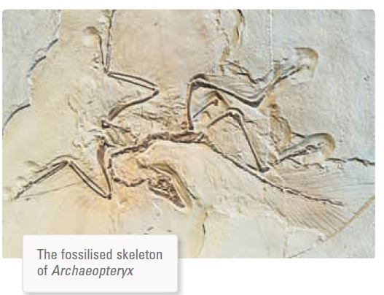
Photo: In Green / Shutterstock.com
(a) Identify the features that survived the fossilisation process.

(b) Explain why these features survived whereas others did not.

(c) Explain the scientific importance of this fossil.

CHAPTER 3: Evolution
Worksheet 3.4

Page 2

Ancient leaves
2. The photo below shows the remains of ancient leaves that have been fossilised.
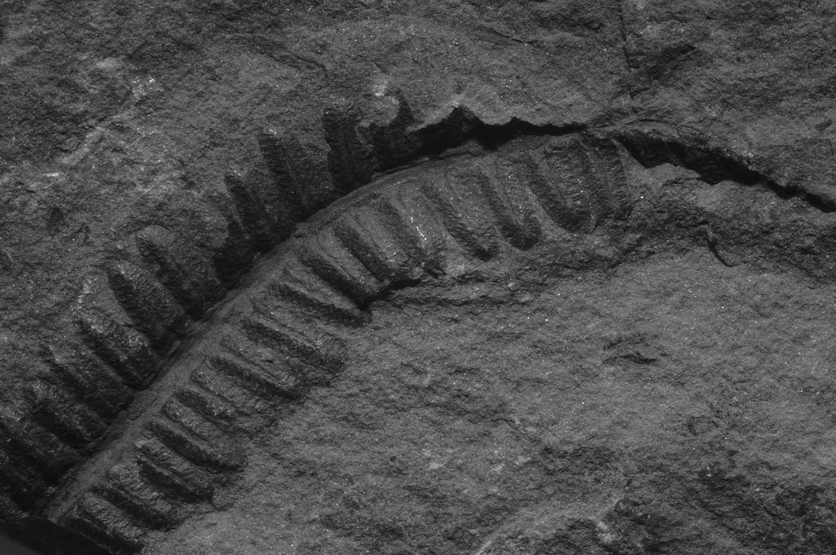
Photo: Baciu / Shutterstock.com
(a) Classify this type of fossil.

(b) Explain how this fossilisation process has occurred.

Insects
3. The photo below shows a fossilised insect.
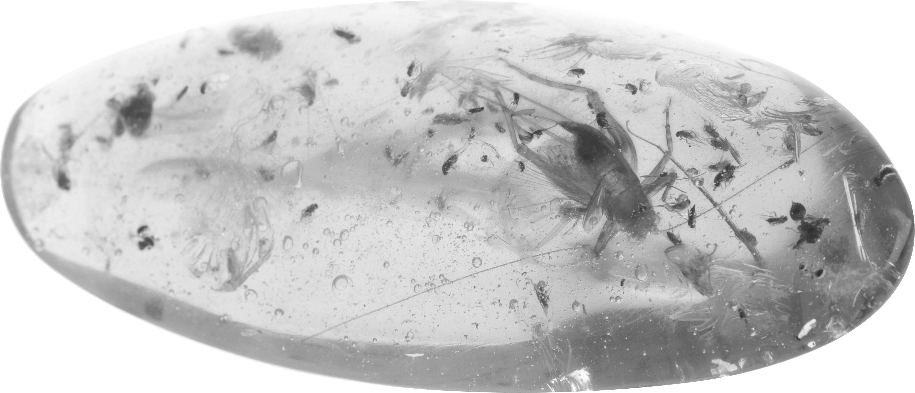
Photo: Roy Palmer / Shutterstock.com
(a) Classify this type of fossil.

(b) Describe how the body of this insect was preserved.

